Chapter 5. Simulation and Performance Evaluation

To verify the feasibility of proposed strategy, we simulate the proposed approach in a cubic indoor environment, 15 \* 20 \* 2.3 ($m^{3}$), by using Python programming language. In section 5.1, we describe the experimental setting. NSGA-II convergence experiments are demonstrated in section 5.2 afterwards. Finally, we compare the proposed method with Jian *et al.*’sSABC approach and Jian *et al.*’s LSABC approach in terms of the number of charging stations and the overall charging power in section 5.3.

5.1 Experimental Setting

In the simulation experiment, the sensor nodes are randomly deployed on the ground. For a charging station, the effectual charging distance is 3(m) and the angle $θ$ is set to 30 $°$ [21]. Number of sensor nodes are set vary from 25 to 125 with increment of 25. According to powercast's products, frequency of charging station is set to 915 *MHz* and the transmission power is 3 *W EIPR*. Note that as the same with other researches, we assume that the charging efficiency is not affected by the number of sensor nodes. In other words, the time required to charge multiple power-depleted sensor nodes is the same as to charge a single one [22, 23] . In order to avoid the algorithm taking too long to execute, we chose a population of 10 as the experimental setting. Before performing the comparisons between the proposed approach and other approaches, the crossover rate and mutation rate should be identified for the proposed NSGA-II approach. The parameters details are shown in Table 1.

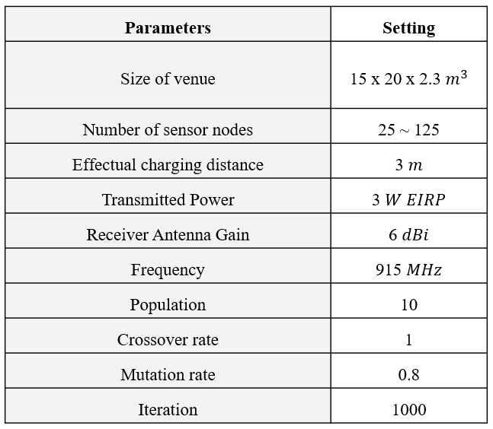Table 1. Simulation parameters

5.2 NSGA-II Convergence Experiment

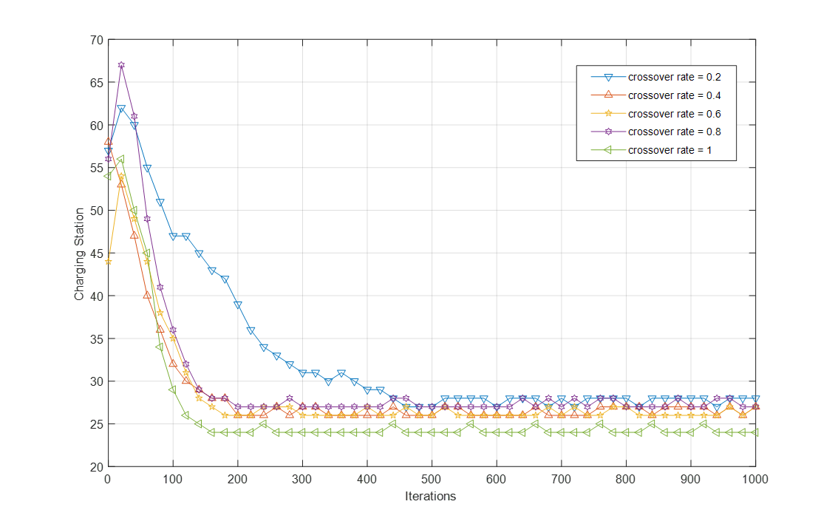 Under the number of charging station, we performed the experiment to observe the convergence behavior of the NSGA-II. In the experiment, the default values of $r_{c}, r_{m} and population$ were set to 100%, 80% and 10, respectively. First, we varied the value of $r_{c}$ from 20% to 100% with increments of 20% to observe the effects on the NSGA-II convergence. The result is presented in Figure 9. From the figure, we observe that the number of charging station is smallest for $r_{c}$ values of 100%. As a result, we set the crossover rate to 100%. This means that every time you will go through the steps of crossover.

Figure 9. Effects of the crossover rate on NSGA-II convergence

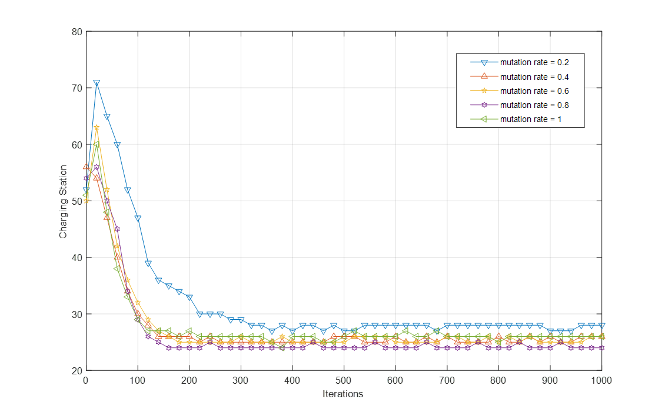Next, we varied the value of $r_{m}$ from 20% to 100% with increments of 20% to observe the effects on the NSGA-II convergence. The result is presented in Figure 10. From the figure, we observe that the number of charging station is smallest for $r_{m}$ values of 80%. As a result, we set the mutation rate to 80%.

Figure 10. Effects of the mutation rate on NSGA-II convergence

5.3 Simulation results

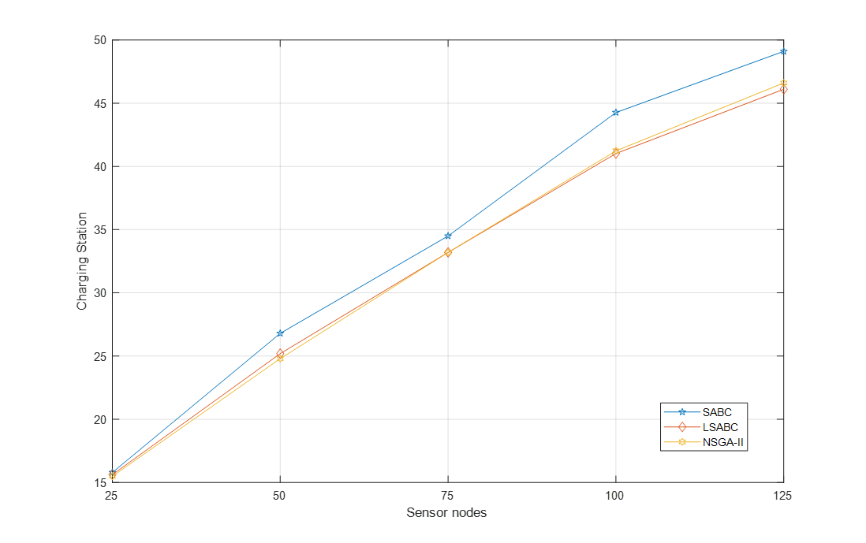In our experiments, the simulations were executed 30 times. We measured the average number of charging station and the average energy received of each sensor node. The Figure 11 shows the comparison of number of chargers with NSGA-II, LSABC and SABC. X-axis represents the number of sensor nodes, and Y-axis represents the number of charging stations. Obviously, the number of charging station of NSGA-II and LSABC is lower than SABC and this phenomenon become evident increasingly when the number of sensor nodes is increased. This is because NSGA-II uses the mechanisms of crossover and mutation and LSABC uses the layoff algorithm to avoid falling into local optimum.

Figure 11. The number of charging station with the number of sensor node increasing from 25 to 125

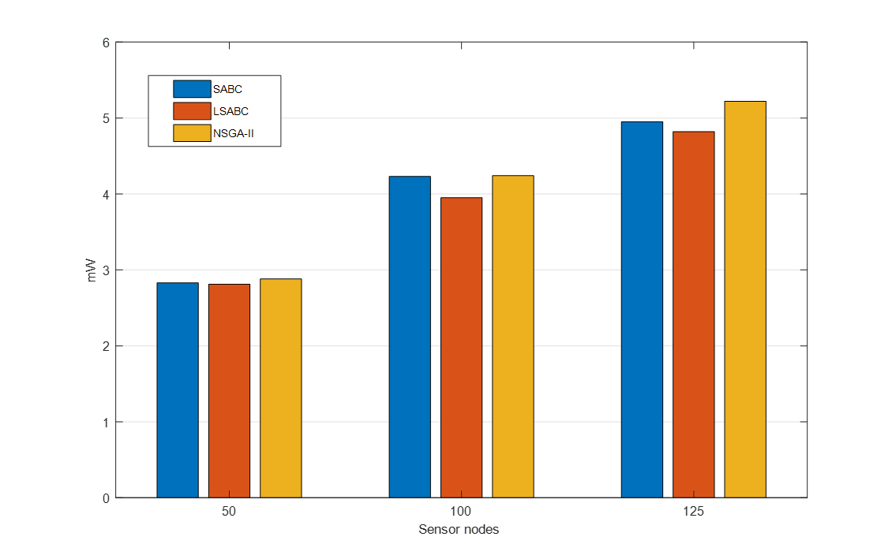The Figure 12 shows the comparison of the average energy received of each sensor node. X-axis represents number of sensor node, and Y-axis represents the average energy received of each sensor node (*mW*). The simulation results that NSGA-II can receive more power than LSABC and SABC, because LSABC and SABC do not take into account the distance between the charging station and the sensor node. When the distance is closer, the sensor can receive more energy.

Figure 12. the average energy received of each sensor node with the number of sensor node increasing from 50 to 125

We also compare the number of charging stations required by different methods under different sensor node number and the overall sensor nodes energy received. The details are shown in Table 2. We can be seen that under the same number of charging stations, the overall energy received by the NSGA-II method is greater than that of other methods. Figures 13-15 show where to place the charging station for different number of sensor nodes

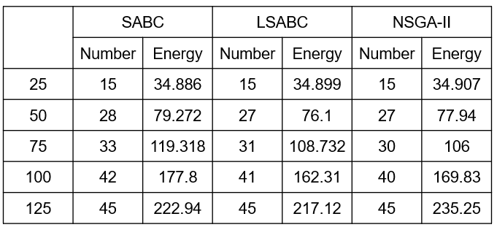Table 2. Charging Station vs. Charging Efficiency in different sensor node number

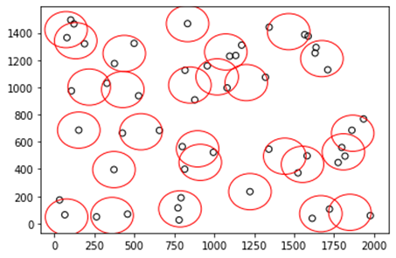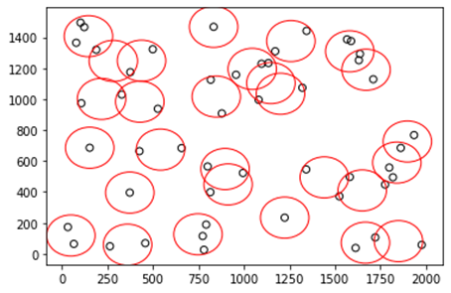(a) SABC has 28 charging stations and sensor nodes with a total received energy of 79.272*mW*

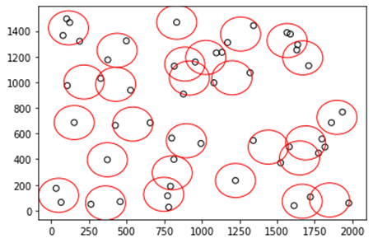(b) LSABC has 27 charging stations and sensor nodes with a total received energy of 76.10*mW*

(c) NSGA-II has 27 charging stations and sensor nodes with a total received energy of 77.94*mW*

Figure 13. Where 50 sensor nodes are placed in charging stations with different methods

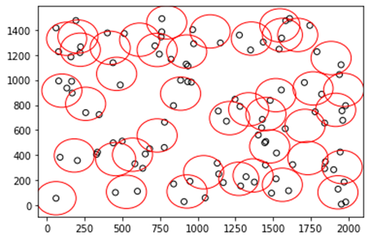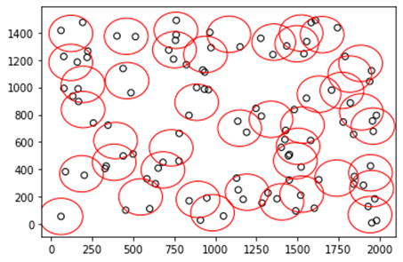(a)SABC has 42 charging stations and sensor nodes with a total received energy of 177.80*mW*

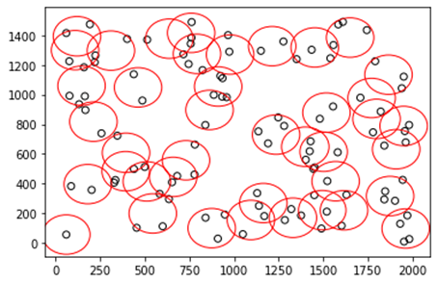(b)LSABC has 41 charging stations and sensor nodes with a total received energy of 162.31*mW*

(c)NSGA-II has 40 charging stations and sensor nodes with a total received energy of 169.83*mW*

Figure 14. Where 100 sensor nodes are placed in charging stations with different methods

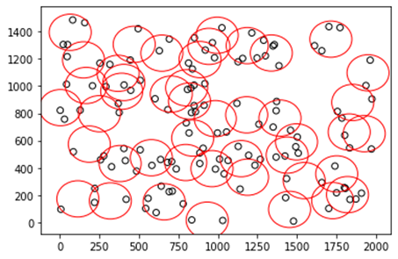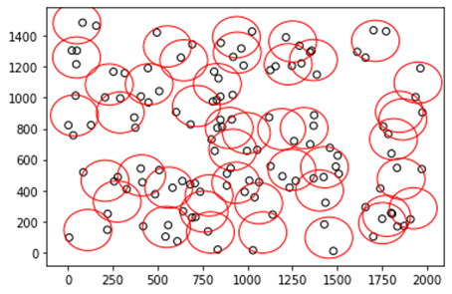(a)SABC has 45 charging stations and sensor nodes with a total received energy of 222.94*mW*

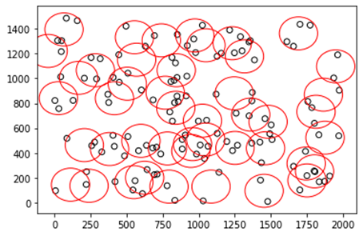(b)LSABC has 45 charging stations and sensor nodes with a total received energy of 217.12*mW*

(c)NSGA-II has 45 charging stations and sensor nodes with a total received energy of 235.25*mW*

Figure 15. Where 125 sensor nodes are placed in charging stations with different methods